Gym Membership Analysis - SQL Query Report

This project analyzes gym membership, customer behavior, attendance, revenue, and renewal patterns using SQL Server and Power BI. The objective is to help gym management make data-driven decisions to improve customer retention and increase revenue.

- SQL Query Section
1. How many members are registered in the gym?
select count(*) as 'Total Member' from Gym_Data
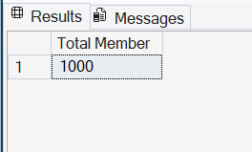

2. How many members have Monthly, Quarterly, Half-Yearly, and Annual memberships?
select MembershipType, count(MembershipDuration) as 'Num of Membership'
from Gym_Data
group by MembershipType
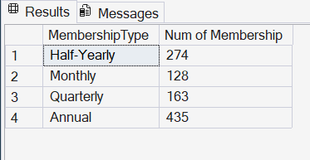

3. Which membership plan generates the highest revenue?
select MembershipType,sum(MembershipFee) as 'Total Revenue'
from Gym_Data
group by MembershipType
order by sum(MembershipFee) desc
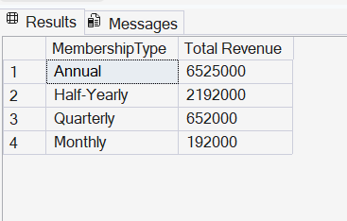

4. Which Top 10 membership plan is preferred by each occupation?
select top 10 MembershipType,occupation,count(*) as 'Total Member'
from Gym_Data
group by MembershipType,Occupation
order by count(*) desc
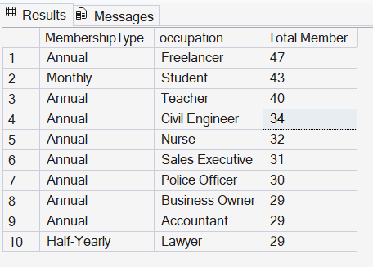

5. Which cities generate the highest revenue?
select city,sum(membershipfee) as 'Total Revenue'
from Gym_Data
group by city
order by sum(membershipfee) desc ,city
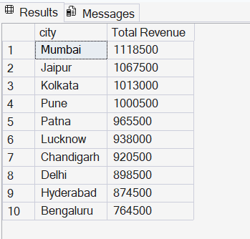

6. Which membership plan has the highest renewal rate?

